SUPPLY CHAIN ANALYSIS
- Executive Summary
This report presents a comprehensive analysis of the delivery operations of a global e-commerce company managing end-to-end order fulfilment across multiple regions. The analysis covers 172,765 orders spanning January 2015 through January 2018, focusing on identifying root causes of chronic late deliveries, quantifying their financial impact, and establishing a data-driven framework for improvement.
The headline finding is stark: 52.71% of all orders are delivered late, costing the business $2.1M in eroded profitability on delayed orders alone. While total profit across fulfilled orders $7.5M, the persistent late-delivery problem represents both a significant financial drain and a major customer experience risk. A Random Forest predictive model achieved 74% accuracy in identifying at-risk orders before they become late.

Key Findings
Overall Late Delivery Rate | 54.71%
On- Time Delivery Rate | 45.29%
Total Orders Analyzed | 172,765
Total Profit (profitable orders) | $7.5M
Profit at Risk (delayed orders) | $2.1M
Predictive Model Accuracy (RF) | 74%

- Business Context & Objectives
The company operates a global e-commerce platform selling products across categories including sporting goods, fitness equipment, outdoor gear, footwear, and apparel across multiple international regions.

Core Business Problem
Actual shipping times frequently deviate from scheduled delivery windows, creating eroded customer trust, reduced order profitability, and an inability to make reliable commitments to buyers at point of purchase.

Analytical Objectives
Understand the current state of delivery performance across all dimensions (region, mode, time, segment).
Qunatify the financial impact of delays on order profitability.
Build a predictive model to flag high-risk orders before they are shipped.
Deliver actionable recommendations to improve on- time delivery and profitability.

- Key Performance Indicators (KPIs)
The following KPIs were computed directly from the cleaned dataset to establish a performance baseline.

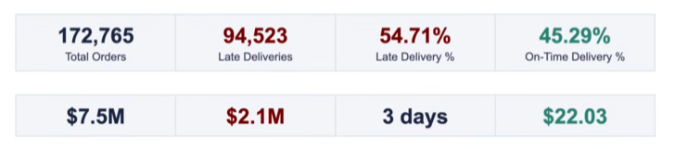

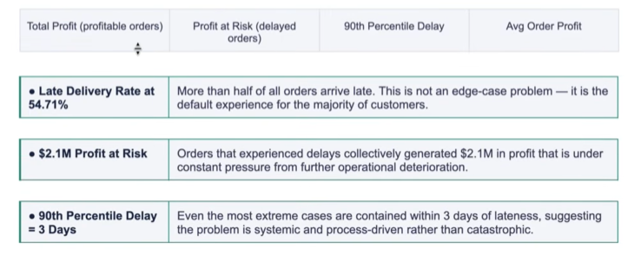
- Profitability Analysis
Profitability Distribution
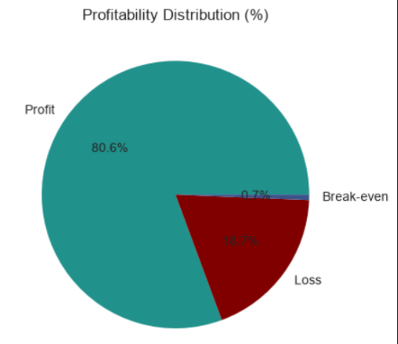
Order-level profitability was classified into three parts based on Order Profit per Order. While 80.7% of orders are profitable, the 18.7% loss-making share represents a meaningful drag that is disproportionately concentrated among delayed shipments.
  - Delay Distribution & Profit vs Delay Days
The delay distribution shows that 31.0% of all orders arrive exactly 1 day late the single largest cohort.
Combines, orders delayed by 1-4 days account for 54.7% of all order volume, directly mapping to the overall late delivery rate.

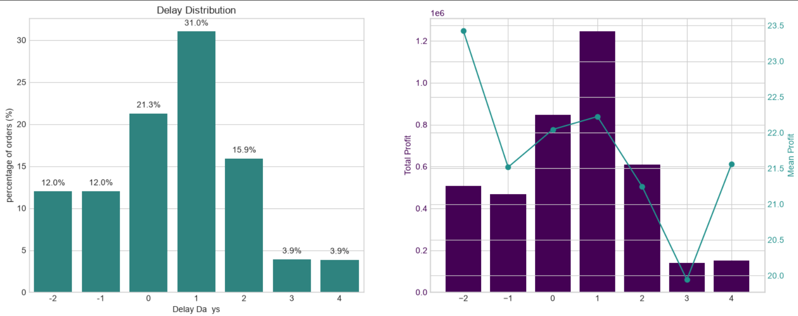
A critical observation: mean profit per order remains stable at approximately $20-$23 across all delay levels. The profitability problem is therefore driven by volume of delayed orders, not by individual order economics making systematic throughput improvement the highest-leverage intervention.

- Bottleneck Detection
Delay percentage was computed across six key operational dimensions. The charts below reveal where the fulfilment process breaks down most severely.

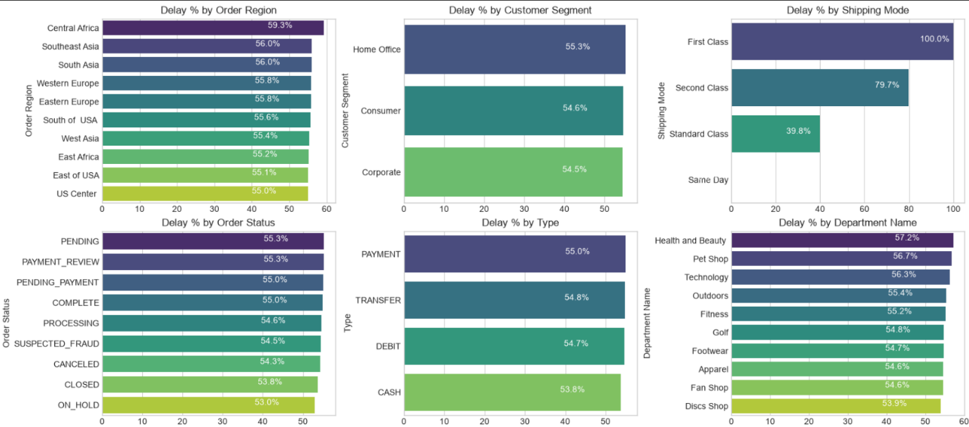
Bottleneck Detection- Delay % by Category

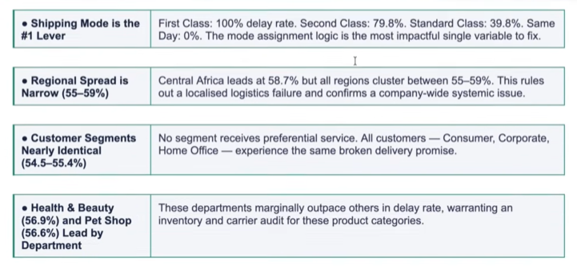
- Root Cause Analysis
Central Africa was selected for deep-dive root cause analysis as the highest -delay region (58.7%). The chart below ranks the top 10 driver factors by delay percentage within this region.
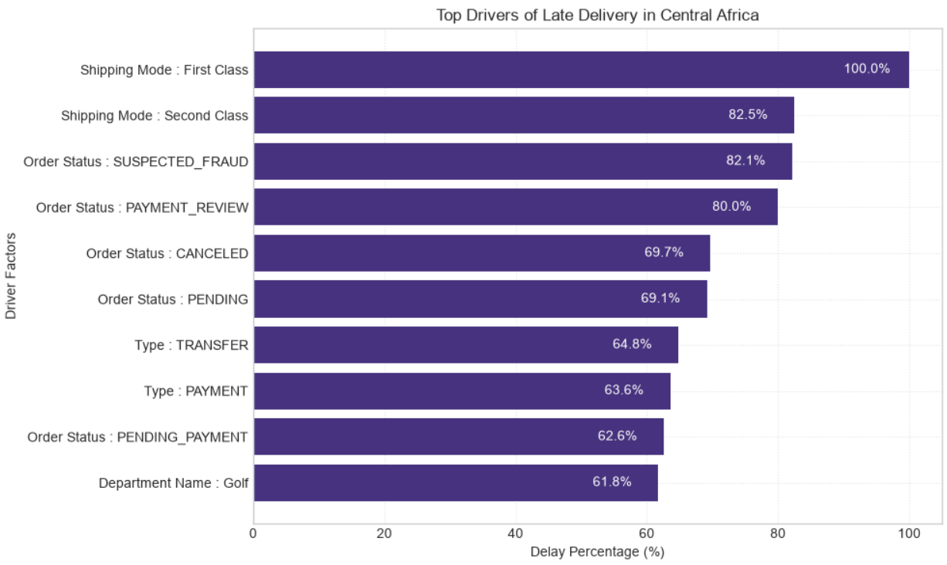
- Time-Based Delay Patterns
Three temporal dimensions were analysed: month of year, day of week and hour of day. While delay rates are relatively stable across all dimensions (53- 57%), specific peaks highlight opportunities for targeted capacity planning.

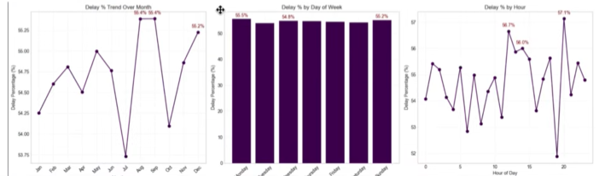

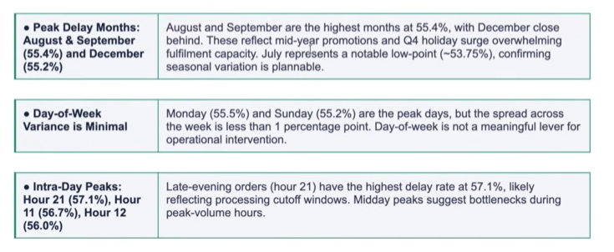

- Machine Learning Model Results
A supervised classification model was built to predict whether an individual order will be delivered late/ The pipeline included frequency encoding of categorical variables, stratified train/test split, SMOTE oversampling to address class imbalance, and Random Forest classification.
Class Imbalance handling(SMOTE)
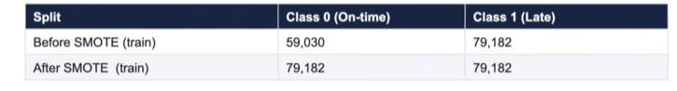
Random Forest Classifier – test Set performance (34,553 records)
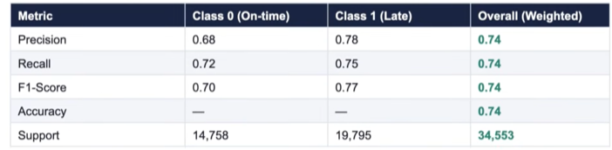

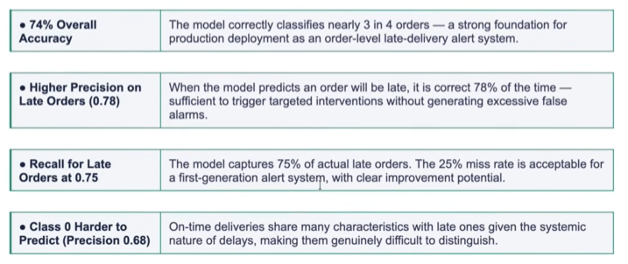

- Strategic Recommendation
Based on the finding across all analytical dimensions, the following prioritized actions are recommended:
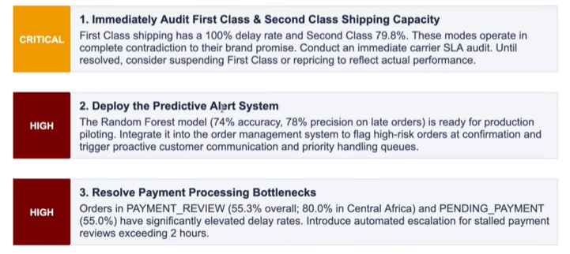
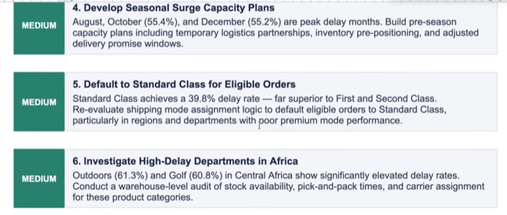

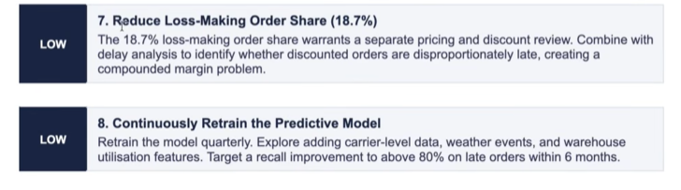

- Conclusion
This analysis has surfaced a clear and urgent picture: a global e-commerce operation where the majority of orders fail to meet their promised delivery windows, costing $2.1M in at-risk profit and undermining customer trust at scale.
The root causes are identifiable and addressable. Shipping mode misconfiguration (First Class at 100% late, Second Class at 79.8%) is the dominant operational failure. Payment processing friction creates a secondary bottleneck. Seasonal volume spikes are not adequately planned for. And geographic disparities, while present, are secondary to the systematic company-wide pattern.
A Random Forest predictive model trained on readily available order features already achieves 74% accuracy in identifying at-risk orders. This is a deployable tool, not a future aspiration.
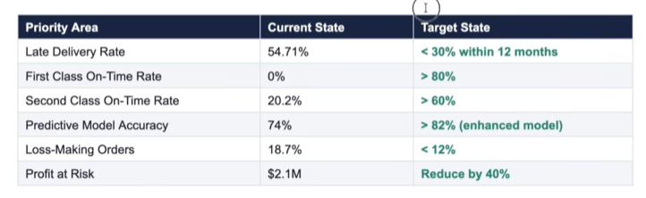
With focused execution on the eight recommendations in this report starting with the critical shipping mode audit and predictive alert system deployment the business can systematically recover its delivery performance, protect its $7.5M profit base, and build the operational reliability that sustained e-commerce growth demands.

